Snow White and the seven dwarfs

Instructie:
- Pak je lijst met onregelmatige werkwoorden in je tekstboek erbij;
- Zoek het betreffende werkwoord op;
- Staat het er in: schrijf de 2e kolom over;
- Staat het er niet in: schrijf achter het hele werkwoord +ED.

Once upon a time there 1 .………….……. (be) a very beautiful girl who 2 .………….……. (be - call) Snow White and she 3 .………….……. (live) in a faraway land. Her mother 4 .………….……. (die) and her father, the king, 5 .………….……. (marry) again with a beautiful woman. Every day the new queen 6 .………….……. (look) into her magic mirror and 7 .………….……. (ask): “Mirror, mirror on the wall. Who is the fairest of them all?” The mirror 8 .………….……. (answer): “You are the fairest in the land.”
But one day the mirror 9 .………….……. (give) a different answer: “Snow White is the fairest in the land.” This 10.………….……. (make) the queen very angry and she 11 .………….……. (tell) her servant to kill Snow White. But the servant 12 .………….……. (can – not) kill her and just left her in the forest. Snow White 13 .………….……. (walk – not) long until she 14 .………….……. (come) to a little house. She 15 .………….……. (feel) hungry and tired. .………….……. she 16 .………….……. (go) inside and 17 .………….……. she (see) .………….……. seven little plates and glasses? Yes and next to the wall 18 .………….……. (stand) seven little beds. Snow White 19 .………….……. (eat – not) some bread and 20 .………….……. (drink – not) some water but she lay down to sleep.
Soon the seven little dwarfs 21 .………….……. (come) back. At first they 22 .………….……. (be) angry but after Snow White woke up and they 23 .………….……. (hear) her story, they 24 .………….……. (feel) sorry for her. They 25 .………….……. (say) she could stay.
The queen 26 .………….……. (be) happy because she thought Snow White 27 .………. (be) dead. Shen she 28 .………….……. (find out) that Snow White 29 .………….……. (be) still alive she 30 .………….……. (make) up a plan. She 31 .………….……. (dress) up as an old woman and 32 .………….……. (go) to the dwarf’s house. When Snow White 33 .………….……. (come) to the door, the queen put a poisoned comb in her hair and Snow White fell to the ground. 34 .………….……. (be) this story true? 35 .………….……. the queen 36 .………….……. (give) the Snow White a poisoned comb?
Soon the dwarfs 37 .………….……. (came) home, 38 .………….……. (take) the comb from Snow White’s hair and 39 .………….……. (bring) her back to life. They 40 .………….……. (tell) her not to let anyone into the house. When the queen 41 .………….……. (find) out that Snow White was alive, she 42 .………….……. (be) angry and she 43 .………….……. (go) to visit Snow White again. This time, Snow White 44 .………….……. (open) the door. But the queen 45 .………….……. (want) to give her a lovely red apple. It 46 .………….……. (be) poisoned on one side. The queen 47 .………….……. (take) a bite and then 48 .………….……. (give) it to Snow White. Snow White
49 .………….……. (think) the apple 50 .………….……. (looked) delicious and 51 .………….……. (take) a bite and suddenly 52 .………….……. (fall) down dead. The queen 53 .………….……. (go) home very happy when the mirror 54 .………….……. (give) her the right answer. And so the story 55 .………….……. (end) or not?

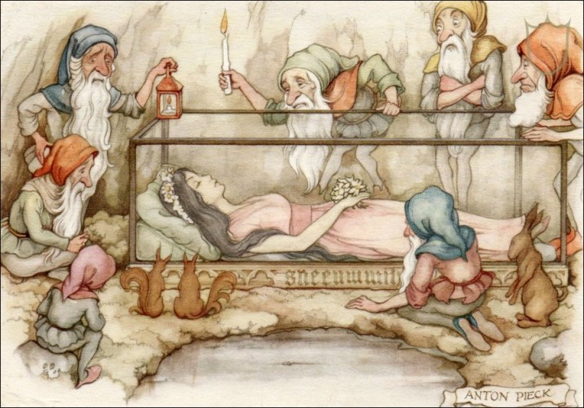

The dwarfs 56 .………….……. (not can) bring Snow White back to life this time but because she 57 .………….……. (look) so beautiful they 58 .………….……. (not want) to bury her. They 59 .………….……. (put) her in a glass coffin. One day a prince 60 .………….……. (come) by and 61 .………….……. (fell) in love with her. He 62 .………….……. (ask)if he 63 .………….……. (can) have the coffin and the dwarfs 64 .………….……. (say) yes.
When they 65 .………….……. (move) the coffin, the piece of apple 66 .………….……. (fall) from Snow White’s lips and she 67 .………….……. (wake up). Soon she 68 .………….……. ( marry) the prince. When the mirror 69 .………….……. (tell) the queen that Snow White 70 .………….……. (be) alive, she 71 .………….……. (become) ill and 72 .………….……. (die). Snow White and her prince 73.………….……. (live) happily ever after.

